Manuscript Template for Journal of Position, Navigation, and Timing (the first letter of each word shall be capitalized and in bold)
Gil-Dong Hong¹, Mong-Lyong Lee¹, Walter Disney², Elsa Arendelle³, Kristen Bell^{1†}
¹Department of Electronics Engineering, Korea GNSS University, Daejeon 35764, Korea
²Department of Ice Engineering, Galaxy University, Xian 30763, China
³Division of Physical Metrology, Research Institute of Ice and Snow, MN 00540, USA

†Corresponding Author
E-mail: Kbell@hsu.ac.kr
Tel: +82-42-000-0000 Fax: +82-42-000-0001
Received Feb xx, 201x Revised Mar xx, 201x Accepted Apr xx, 201x (Do not change this line)
Gil-Dong Hong https://orcid.org/0000-0002-5324-7300
Mong-Lyong Lee https://orcid.org/0000-0002-4163-7311
Walter Disney https://orcid.org/0000-0002-6617-6689
Elsa Arendelle https://orcid.org/0000-0002-6516-3210
Kristen Bell https://orcid.org/0000-0002-6148-5548

Heading Title: Gil-Dong Hong et al. Manuscript template (heading short title)
Article type: Research Paper

ABSTRACT

Section headings such as ABSTRACT, 1. INTRODUCTION, and REFERENCES shall be capitalized, and subsection or subsection headings shall have only the first letter of each word capitalized. All headings other than subsections shall be in bold. The abstract, acknowledgments and references shall not be numbered. For more information, please check the full guidelines posted on the IPNT website (http://www.ipnt.or.kr).

Keywords: snow, queen (less than 5 keywords, small letter)

1. Introduction

Manuscripts shall be prepared in the following manner: Title, Author name, Mailing address, Phone and fax number, e-mail address, Heading (shorter version of the title that is to be printed in the upper-right corner of each page), Abstract, Keywords, Main text, Acknowledgments (optional), References, Appendices (optional), Figure captions, Table captions, Figures, Tables. Figures, figure captions, tables and table captions shall be inserted after the references in principle, but are also permitted to be inserted in the main text.
Sections and subsections shall be organized in the order of 1., 1.2, and 1.2.1 if necessary.
Abbreviations shall be given in full names when mentioned for the first time. The full names shall be included once again in the main text even if the abstract has already mentioned them. For example, Global Navigation Satellite System (GNSS).
Symbols of elements shall be written in Roman type and not italicized. SI units and astronomical units shall be used in common abbreviations (cm, m, km, A.U., pc, arcsec, Mpc, mag, etc.). All sentences shall not begin with symbols or numbers.
The references cited in the main text shall precisely match the list of references. All tables and figures included in the paper shall be cited within the main text with the necessity justified.

2. Main Topics

2.1 How to Cite References (only the first letter of first word shall be capitalized)

Articles that are cited shall be written using the author's last name and year of publication at the relevant section of the paper as shown follow: Ex.1) . . . (Hale 1929). Do not put a comma before the year, Ex.2) Hale & Kim (1929) found…, Ex.3) Hale et. al. (1929) or (Hale et al. 1929). If there are 2 or 3 authors, use the symbol "&" instead of "and". If there are 3 authors, put a comma before "&", for example: Hale, Kim, & Lee (1968). If there are 3 or more authors, use "et al." when making citations in the main text. Use a normal font instead of italics, and put a period at the end. But in references, if there are 5 or more co-authors write only up to 5 names and mark the rest with "et al."
When citing two or more articles published by the same author in the same year, they shall be differentiated using symbols such as "a, b, c" next to the year. The same rule also applies to the references: Ex.1) Hale (1929a), Ex.2) Hale (1929a,b)

2.2 References (only the first letter of first word shall be capitalized)

References shall be provided in alphabetical order of the authors' names. If there are multiple articles by the same author, write the article in the order of publication. If there are articles by a single author and co-authors including the same person, the article published by a single author shall be provided first. References shall be written in English even if the original article cited is written in Korean.
If one of the reference data is too long and it moves on to the next line, make an indentation starting with the next line. Papers in publication or that are in preparation for publication shall be marked “in press”, “submitted”, and “in preparation”. If there are 2 or more authors, put "&" before the last author. If there are 3 or more authors, put a comma before "&". : Hale, J. R., Tayler, R. J., & Suwart, K. R. 1993, . . .
The title of the journal shall be summarized according to the general standard of the SCI academic journals. Write the volume in Arabic numerals for journal articles, and as "vol.2" for books in series.

3. Euations, tables and Figures

3.1 Equations (only the first letter of first word shall be capitalized)

All equations shall be centered. Mark all equations with the serial number (1), (2), ... on the right side of the page. When citing equations, mark them with Eq. (3), Eqs. (3,5), Eqs. (3-6). To mark vectors, write the text in bold instead of using arrows above the text. Do not write a title for an equation.
Ex: Noise and sampling time. Variance of can be obtained in Eqs. (1) and (2).

(1)
(2)

where denotes variance of , and variance of . It can be seen that variance of the driving noise for computer simulation can be obtained the ….

3.2 Tables (only the first letter of first word shall be capitalized)

Do not use vertical lines in any of the tables, but use only horizontal lines. All tables shall have the serial number in Arabic numerals, which shall be used to mark "Table 1" or "Tables 1 and 2" when making a citation. All tables shall have a brief title. The title shall be located above the table, and have a period at the end. Tables shall be centered. When organized with the text, they shall be located at the top or bottom of the page. All horizontal lines of tables shall be used at the bottom section above the table column heading and last section in single lines. Each column heading shall be in simple words and the first letter capitalized. When necessary, footnotes can be used under the table using Arabic numerals in superscripts. Unit symbols are to be included not on the body of the table, but on the column headings. Do not put special effects such as shading on the tables.
Ex.1) Fig. 1 shows …. Comparing these values with random constant bias of 5, and drift bias of 8 given in Table 1, it can be seen that the gyro output data in Fig. 1 ….
Ex.2) IMU data were generated using the error characteristics of the SiIMU02 IMU given in Table 1 and 3.1.

3.3 Figures (only the first letter of first word shall be capitalized)

All figures shall have the serial number in Arabic numerals, "Fig. 1” or “Figs. 1 and 2” when making a citation. All figures shall have adequate captions containing the explanations of the contents, lines and symbols to improve understanding. Put figure captions below the figures and align text on both sides. Figures as well as texts in the figures shall meet the resolution requirement of 600dpi and above. Texts in the figures shall be as close to 11pt font size as possible when printed so that they match the main text. Figures shall be done in black and white printing. But if color printing is required, this is allowed on the assumption that the author covers the additional costs. All graphs shall have borders on all four sides, and a clear indication of the name of each axis, numbers and units.
For other general figures (schematic diagrams, flowcharts, etc.), borders are not required. When forming a single figure by combining multiple figures, put captions such as (a), (b), (c) clearly inside the figure. For photographic data, the original shall be submitted if good results are not available with half-tone printing. In this case, the author is required to cover the additional printing cost. All figures shall be submitted in electronic files. If figures are submitted separately from the main text, they shall be labeled with a file name and the serial number for figures at the bottom of figure printing. All figures shall be centered. When organized with the text, they shall be located at the top or bottom of the page.
Ex: In Figs. 2, 3, and Table 2, the Root-Sum-Square (RSS) navigation errors for …

4. Conclusions

The basic publication fee for general papers is KRW 100,000, and KRW 10,000 per page (example: a 10-page paper, KRW 100,000 + 10 pages x KRW 10,000/page = KRW 200,000). The basic publication fee for urgently processed papers is KRW 100,000, and KRW 20,000 per page (example: a 10-page paper, KRW 100,000 + 10 pages x KRW 20,000/page = KRW 300,000). If color printing is required, the author pays for the additional costs. The publication fee is subject to change without prior notification upon the decision of the board according to the KGS (Korean GNSS Society) circumstances. The publication fee shall be deposited in the designated account within 7 days after receiving the bill. If the publication fee is not paid, the relevant author (as well as co-authors) may be deprived of submission rights in the future.

Acknowledgments (optional)

This research was supported by Basic Science Research Program through the NRF (National Research Foundation) of Korea funded by the Ministry of Education, Science and Technology (XXXXXXXX).

Author Contributions

The Manuscript with several authors, a short paragraph specifying their individual contributions must be provided. The following statements should be used “conceptualization, X.X. and Y.Y.; methodology, X.X.; software, X.X.; validation, X.X., Y.Y. and Z.Z.; formal analysis, X.X.; investigation, X.X.; resources, X.X.; data curation, X.X.; writing—original draft preparation, X.X.; writing—review and editing, X.X.; visualization, X.X.; supervision, X.X.; project administration, X.X.; funding acquisition, Y.Y.”. Authorship must be limited to those who have contributed substantially to the work reported.

Conflicts of Interest

Authors must identify and declare any personal circumstances or interest that may be perceived as inappropriately influencing the representation or interpretation of reported research results. Declare conflicts of interest or state “The authors declare no conflict of interest.”

References (arrange in alphabetical order of author name)

Journal articles:
Bezick, S. M., Pue, A. J., & Patzelt, C. M. 2010, Inertial navigation for guided missile systems, Johns Hopkins APL Technical Digest, 28, 331-342
Hulsing, R. 1998, MEMS inertial rate and acceleration sensor, IEEE Aerospace and Electronic Systems Magazine, 13, 17-23
Lee, J.-H., Lee, D.-Y., Park, M.-Y., Kim, K.-C., & Kim, H.-S. 2011, Magnetic turbulence associated with magnetic dipolarizations in the near-tail of the Earth’s magnetosphere: Test of anisotropy, JASS, 28, 117-122. http://dx.doi.org/10.5140/JASS.2011.28.2.117 (write doi if possible)

Book, Book in series:
Brown, R. G. & Hwang. P. Y. C. 1997, Introduction to Random Signals and Applied Kalman Filtering, 3rd ed. (New York: John Wiley & Sons)
Holmberg, E. 2975, Magnitudes, colors, surface brightness, intensity distributions absolute luminosities, and diameters of galaxies, in Stars and stellar systems, vol. 9, Galaxies and the universe, eds. Sandage, A., Sandage, M., Kristian, J. (Chicago: Univ. Chicago Press), pp.123-157
Kaplan, E. D. & Hegarty, C. J. 2006, Understanding GPS: Principles and Applications. 2nd ed. (Boston: Artech House Inc.)

Articles from book, conference or symposium proceeding:
Huchra, J. P. 1986, On the determination of cosmological parameters, in Inner space/outer space, eds. Kolb, E. W., Turner, M. S., Lindley, D., Olive, K., Seckel, D. (Chicago: Univ. Chicago Press), pp.65-71
Kim, K., Hwang, J., & Sung, S. 2007, Geosynchronous magnetic field variations associated with the passage of interplanetary shocks or solar wind discontinuities, in 2007 AGU Fall Meeting, San Francisco, CA, 10-14 Dec 2007

Technical report:
Mazanek, D. D., Roithmayr, C. M., Antol, J., Park, S-Y., Koons, R. H., et al. 2005, Comet/asteroid protection system (CAPS): preliminary space-based system concept and study results, NASA Langley Research Center Technical Report, NASA/TM-2005-213758

Dissertation:
Park, S. Y. 1996, Optimization and guidance of ascent trajectories with inequality constraints, PhD Dissertation, Texas A&M University.

Website:
National Radio Astronomy Observatory, Very long baseline array [Internet], cited 2011 Feb 20, available from: https://science.nrao.edu/facilities/vla.

Photograph and brief biography of all authors

Photo | Gil-Dong Hong received the Doctor’s degree in Electronics from Galaxy National University in 2009….………………………………………………………………………………………………………………………………………………………………………………………………………………………………………………………………………………

Figures and tables shall be located at the end of paper with captions.
Table 1. Predicted GOCI MTF performance before launching at Nyquist frequency.
Spectral  band | E/W |  | S/N
 | Requirement | Estimated  performance | Requirement | Estimated  performance
B1  B2  B3  B8 | 0.40  0.39  0.38  0.32 | 0.45  0.48  0.46  0.40 | 0.34  0.33  0.32  0.26 | 0.42  0.41  0.42  0.32

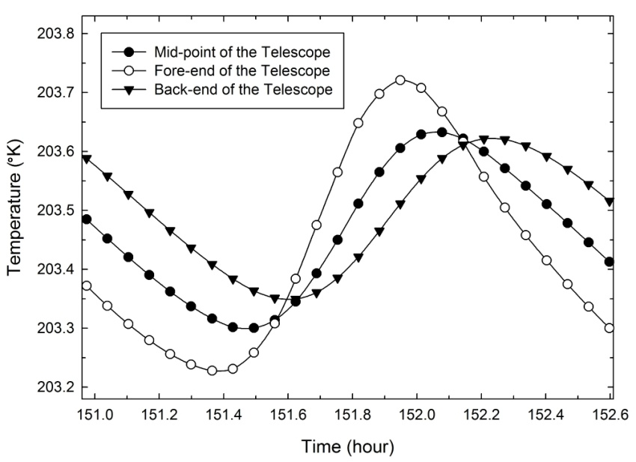
Fig. 1. Temperature of 3 points of the telescope for the attitude of worst hot case and for the radiator's emissivity of 0.85 at the steady state.

